**Studio 8**

**Detailed OO Design**

Jay Patel

Christian Klein

Joseph Thill

Derek Yu

Zifeng Jiang

**Class Diagram**

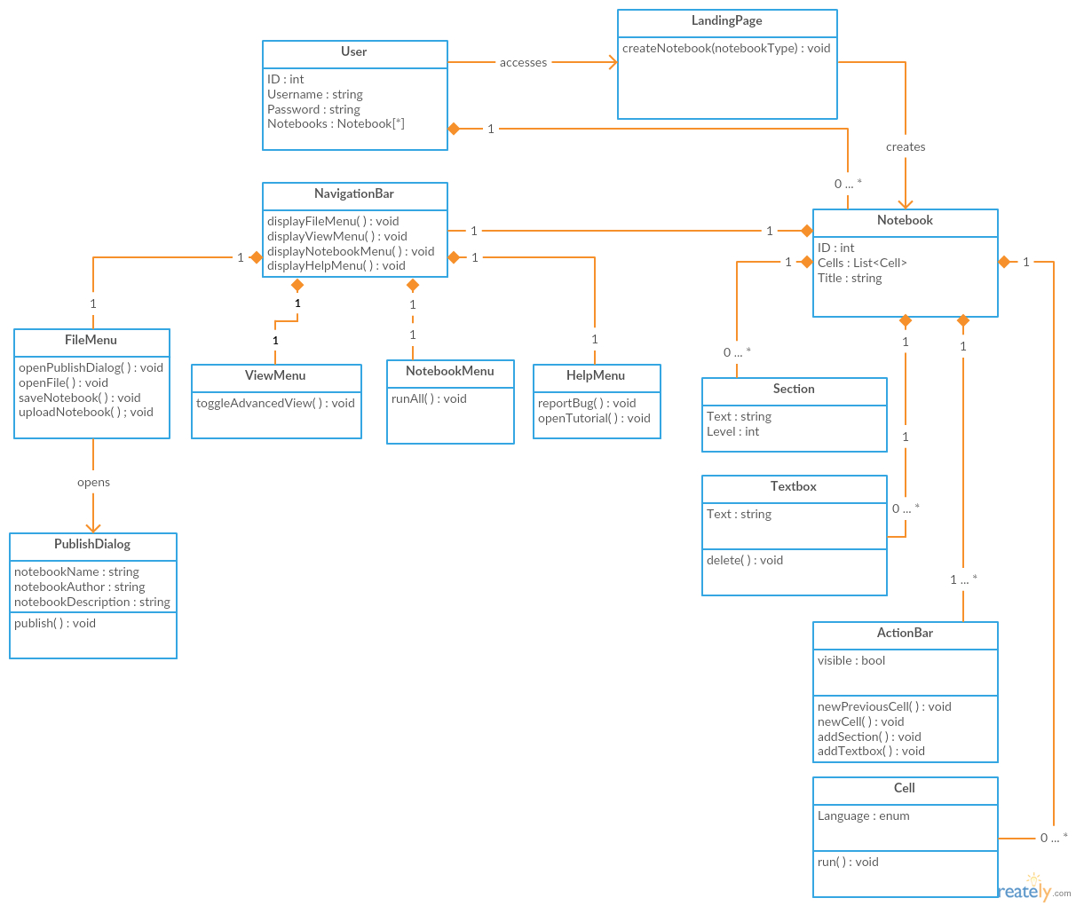

**Interaction Diagrams**

**Use Case 1 - New Previous Cell**

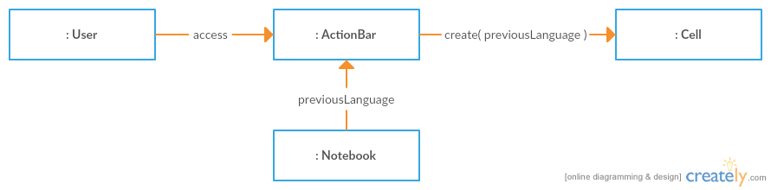

**Use Case 2 - Create New Empty Workbook**

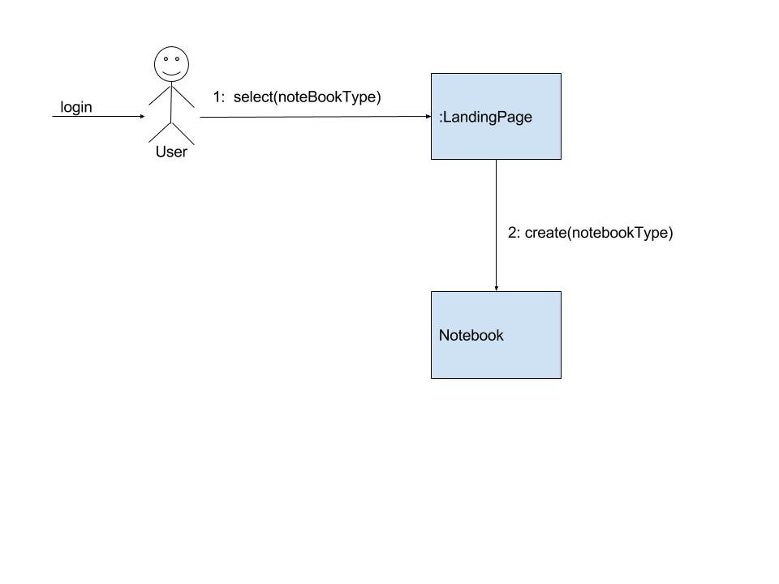

**Use Case 3 - Report Bug**

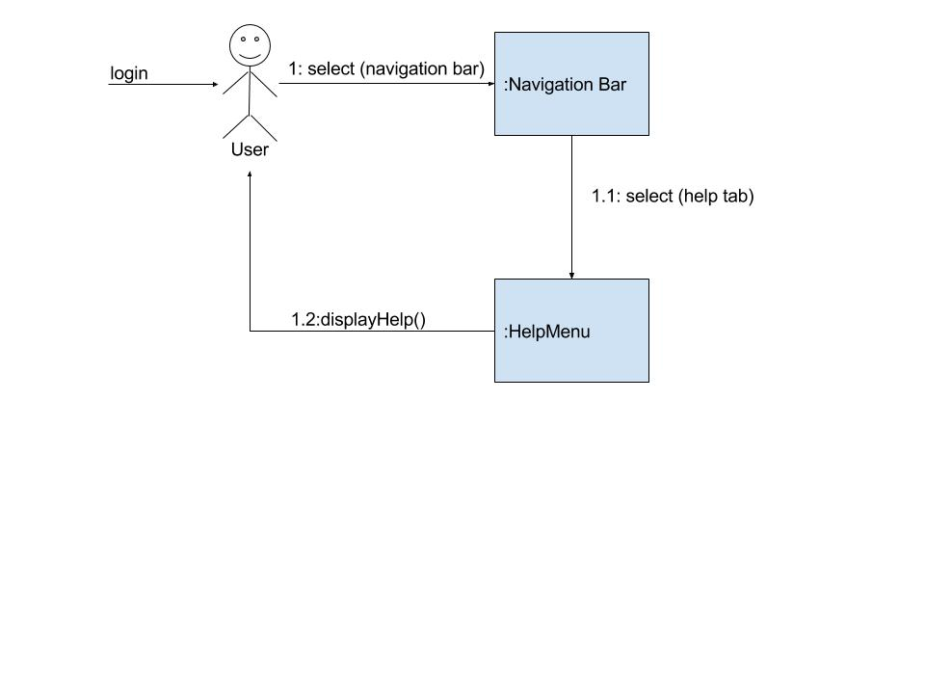

**Use Case 4 - Switch to Advanced View**

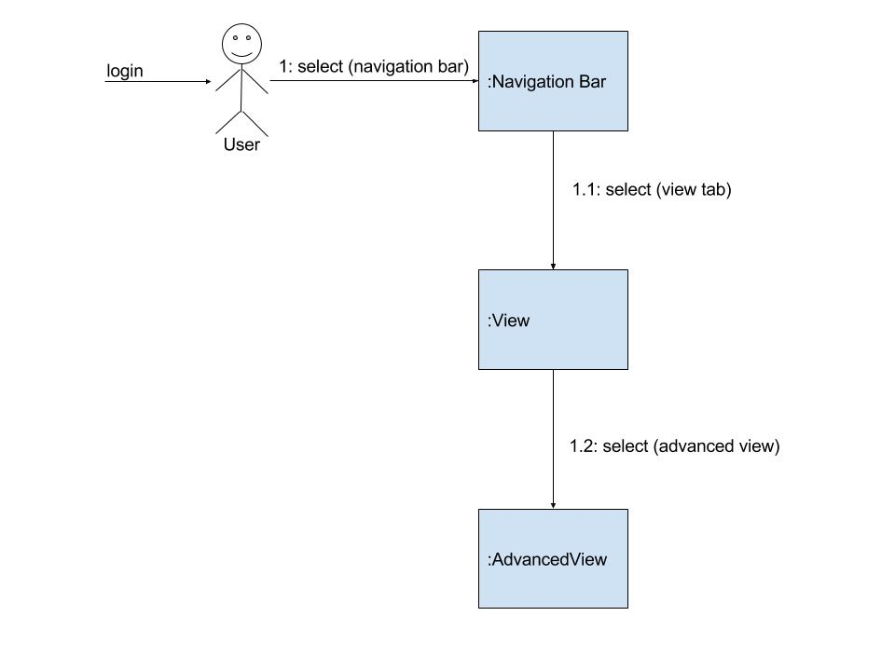

**Use Case 5 - New Cell**

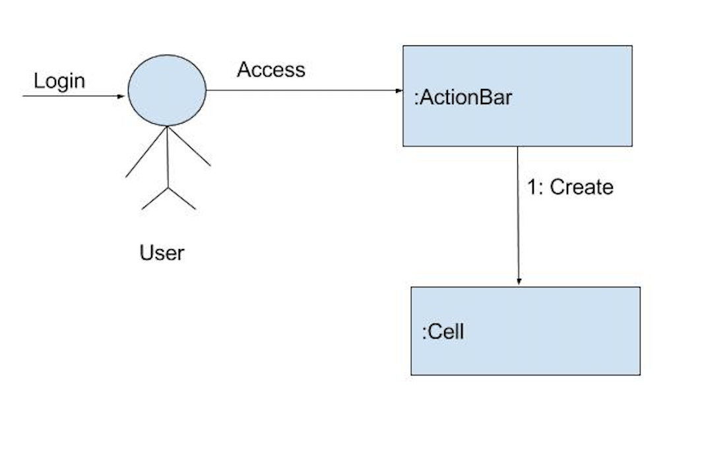

**Use Case 6 - New Textbox**

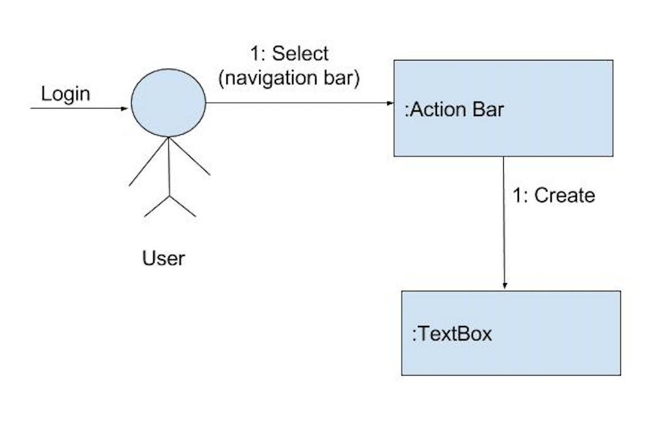

**Use Case 7 - Run Cell**

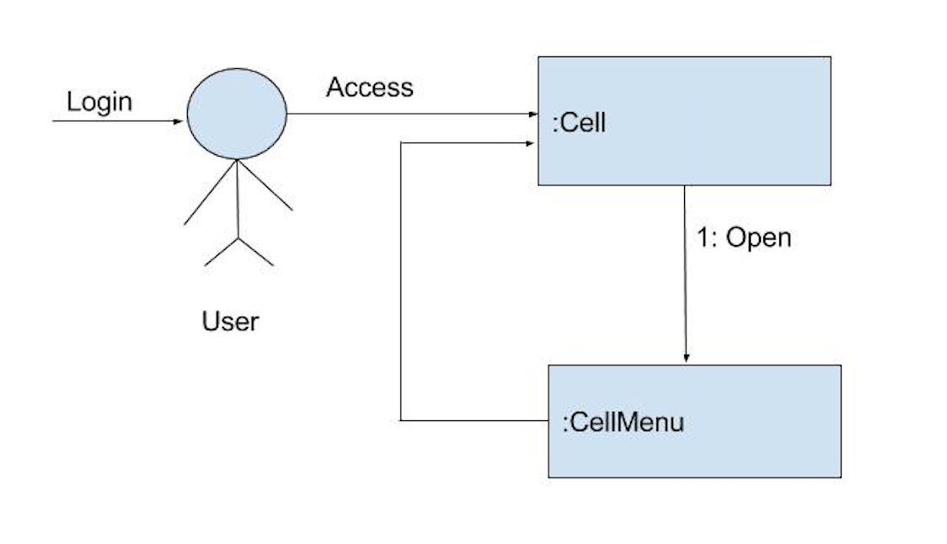

**Use Case 8 - Open Javascript Tutorial**

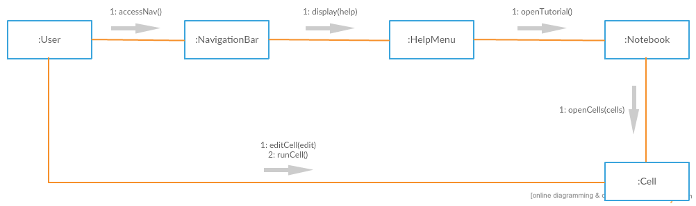

**Use Case 9 - Upload File**

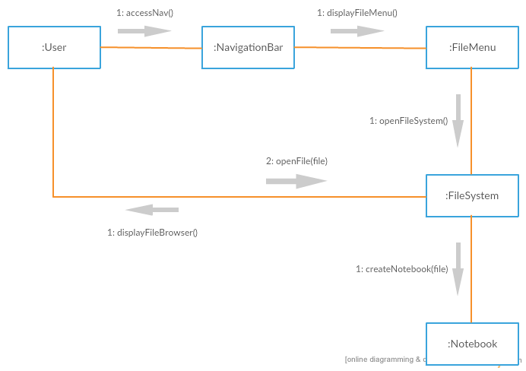

**Use Case 10 - Publish**

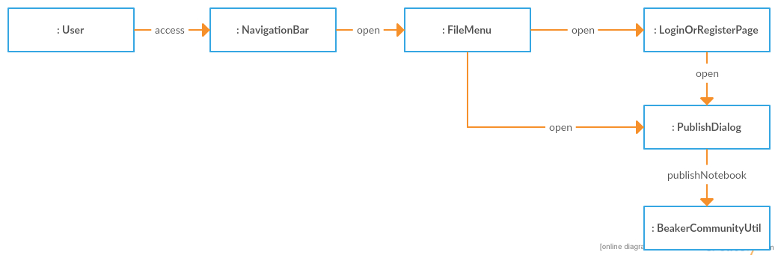

**Use Case 11 - Delete Cell**

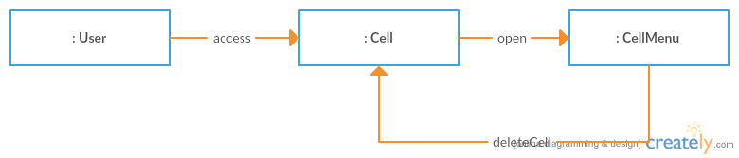

**Use Case 12 - Save Notebook**

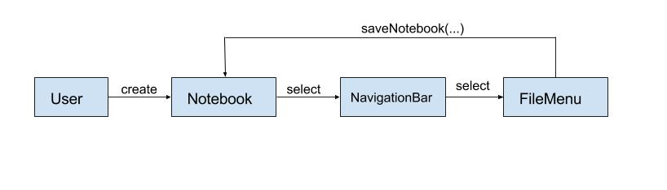

**Use Case 13 - Create Sections**

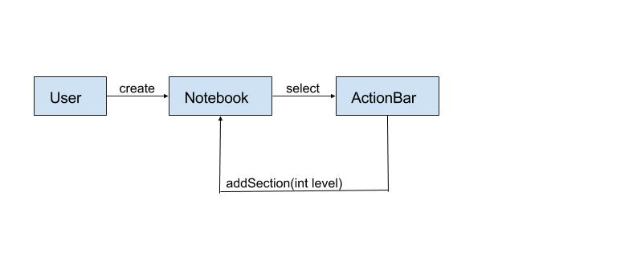

**Use Case 14 - Run All Cells**

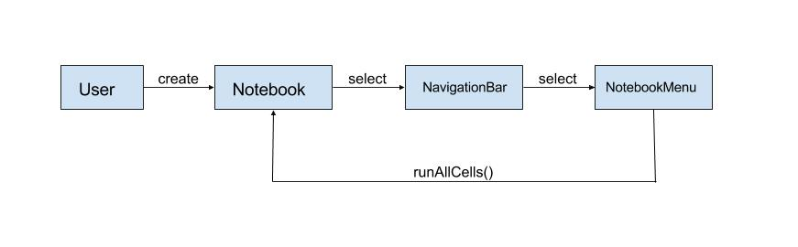

**Class Implementation**

**User**

public class User {

private int id;

private String username;

private String password;

private Notebook[] Notebooks;

public void select(Object o);

}

**LandingPage**

public class LandingPage {

public void createNotebook(notebookType);

}

**Notebook**

public class Notebook {

private int id;

private List<Cell> cells;

private String title;

public cell openCells(cells);

}

**NavigationBar**

public class NavigationBar {

public void displayFileMenu();

public void displayViewMenu();

public void displayNotebookMenu();

public void displayHelpMenu();

}

**FileMenu**

public class FileMenu {

public void openPublishDialog();

public void openFile();

public void saveNotebook();

public void uploadNotebook();

}

**ViewMenu**

public class ViewMenu {

public void toggleAdvancedView();

}

**NotebookMenu**

public class NotebookMenu {

public void runAll();

}

**HelpMenu**

public class HelpMenu {

public void reportBug();

public void openTutorial();

}

**PublishDialog**

public class PublishDialog {

private String notebookName;

private String notebookAuthor;

private String notebookDescription;

public void publish();

}

**Section**

public class Section {

private String text;

private int level;

}

**TextBox**

public class Textbox {

private String text;

public void delete();

}

**ActionBar**

public class ActionBar {

private bool visible;

public Language getPreviousLanguage(Notebook n);

public void newPreviousCell();

public void newCell();

public void newSection();

public void newTextbox();

}

**Cell**

public class Cell {

private Language lang;

public Cell(Language lang);

public void run();

public void addText();

public void delete();

}

**Com S 362 — Object-Oriented Analysis and Design**

**Certification of Individual Contribution and Understanding Form**

Project Name: Detailed OO Design Team Facilitator: Joe Thill

Homework Set: Studio #8 Date: 10-24-2016

Directions: Enter each team member’s name, and a “work rating” (1 - 5 with 5 as high and 1 as low score) that corresponds to the relative share of work done by the team member. Comments to explain work ratings other than 3 must also be provided. The total of the ratings must add up to 3 times the number of team members. Each team member must sign at the end of the form showing your agreement to your team member’s contribution.

*The work rating will have a direct and significant effect on each student’s project and ultimately course grade. In fairness to all students, each team member must give this rating their attention.*

Also, each team member should individually rate the percentage that they understand of the solution. (This does not affect the grade, but is used as a means of communication.)

|  |  |  |  |
| --- | --- | --- | --- |
| Printed team member’s name | Work  Rating  (1 - 5) | Comments/Explanations | Understanding  Self Rating  (0 to 100%) |
| Christian Klein | 3 |  | 90% |
| Derek Yu | 3 |  | 90% |
| Jay Patel | 3 |  | 90% |
| Joe Thill | 3 |  | 90% |
| Zifeng Jiang | 3 |  | 90% |
| Total: | 15 |  | |

Note that you must make Total = 3 * (Number of team members)

|  |
| --- |
| I agree to the above ratings and understand our team’s solution. |
| Christian Klein |
| Derek Yu |
| Jay Patel |
| Joe Thill |
| Zifeng Jiang |